Example:

Transformation of Points in Coordinate Plane

Objective: To describe intuitively the effects of transformation (such as translation, reflection with respect to lines parallel to x-axis and rotation about the origin through multiples of 90°) on points in coordinate planes

Key Stage: 3

Learning Unit: Rectangular coordinate system

Materials Required: Dynamic geometry software such as Cabri Geometry II and Cabri files Tra02.fig, Tra03.fig, Ref02.fig and Rot02.fig

Prerequisite Knowledge: Locating the coordinates of a point in coordinate plane.

Description of the Activity:
- The teacher gives a brief introduction on the geometric meaning of translation, reflection and rotation.
- The teacher distributes Worksheet 1: “Translation of Points in Coordinate Plane” to students. Students need to use the Cabri file Tra02.fig and Tra03.fig to explore the effect of translation of points in the coordinate plane and write down their findings in the worksheets.
- The teacher discusses the answers for Worksheet 1 with students and concludes that ( x , y ) → ( x + a , y + b ) represents the translation of a point by a units horizontally and b units vertically, no matter the points lie in the grid or not.
- The teacher distributes Worksheet 2 “Reflection of Points in Coordinate Plane” and Worksheet 3 “Rotation of Points in Coordinate Plane” to students. Students have to make use of the Cabri files Ref02.fig and Rot02.fig to explore the effect of rotation and reflection of points in the coordinate plane and write down their findings in the worksheets.
- The teacher discusses with students the answers for the worksheets.
- For Worksheet 2, the teacher may conclude that the x-coordinate of the point remains unchanged if the line of reflection is parallel to the x-axis.
- For Worksheet 3, the teacher may conclude that ( x , y ) → ( y , − x ) represents a rotation of the point through 90°. The teacher can guide students to discover that rotating through 180° is the same as rotating 90° twice.
That is, ( x , y ) → ( y , − x ) → ( −x , − y ) is the same as ( x , y ) → ( −x , − y ).
90°
90°
180°

Worksheet 1: Translation of Points in Coordinate Plane
- Open the Cabri file Tra02.fig. You can find the indication of the translation from the origin O to a point P (see Fig.1).
Fig.1
- Select Point from the Points toolbox. Move the cursor to the grid point in the plane and click once to create a point. Label it as A.
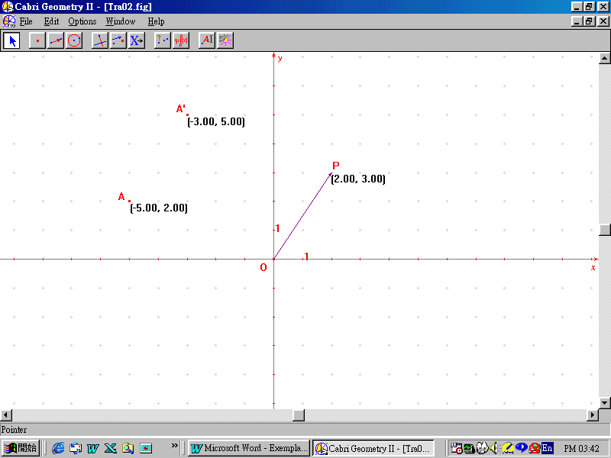
- Select Translation from the Transformation toolbox. Click the point A and the vector respectively to translate the point A by the given translation. Label the translated point as A'. Select Equation and Coordinate from the Measure toolbox. Click the points A and A' to measure their coordinates (see Fig.2).
Fig.2
- Now drag the point A to observe the changes in the coordinates of points A and A'. Without changing the translation, record a set of coordinates of A and its translated point A' in Table 1. Then change the translation by dragging point P. Record other sets of data and fill in the conclusion in the same table.
Translation | Coordinates of the point A | Coordinates of the point A'
From O to ( , ) | ( , ) | ( , )
 | ( , ) | ( , )
 | ( , ) | ( , )
 | ( , ) | ( , )
From O to ( , ) | ( , ) | ( , )
 | ( , ) | ( , )
 | ( , ) | ( , )
 | ( , ) | ( , )
From O to ( , ) | ( , ) | ( , )
 | ( , ) | ( , )
 | ( , ) | ( , )
 | ( , ) | ( , )
 | Conclusion
Translation | Coordinates of the point A | Coordinates of the point A'
From O to (a, b) | ( x , y ) | ( , )
Table 1
- Open the Cabri file Tra03.fig. You will find that the point P may not be lying in the grid. Does your conclusion in Table 1 still hold for points not lying in the grid?
_________________________________________________________________
(You may repeat steps 2 and 3 above to do your own investigation in answering the above question.)
Worksheet 2: Reflection of Points in Coordinate Plane
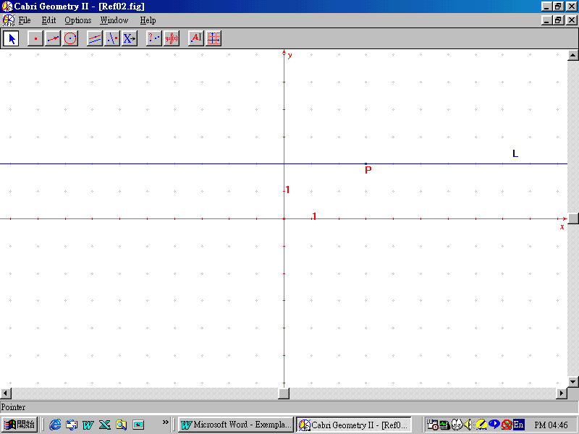
- Open the Cabri file Ref02.fig. You can find a line L which is parallel to x-axis. P is a point lying on the line L (see Fig.1).
Fig.1
- Select Point from the Points toolbox. Move the cursor to the grid point in the plane and click once to create a point. Label it as A.
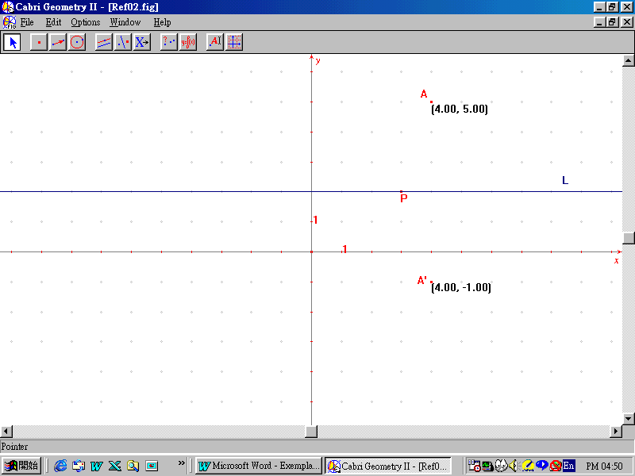
- Select Reflection from the Transformation toolbox. Click the point A and the line L respectively to reflect the point A by the given line L. Label the reflected point as A'. Select Equation and Coordinate from the Measure toolbox. Click the points A and A' to measure their coordinates (see Fig.2).
Fig.2
- Drag the point P so that L becomes the x-axis. Drag the point A to observe the changes in the coordinates of points A and A'. Record a set of coordinates of A and its reflected point A' in Table 1 and fill in the conclusion. Then drag the point P to (1, 2) so that L is 2 units above the x-axis. Record another set of data and fill in the conclusion in Table 2. Repeat the above for a new position of P as (1, -3) so that L is 3 units below the x-axis.
Axis of reflection  (The line L) | Coordinates of the point A | Coordinates of the point A'
the x-axis | ( , ) | ( , )
 | ( , ) | ( , )
 | ( , ) | ( , )
 | ( , ) | ( , )
 | Conclusion
the x-axis | ( x , y ) | ( , )
Table 1

Axis of reflection  (The line L) | Coordinates of the point A | Coordinates of the point A'
2 units above the x-axis | ( , ) | ( , )
 | ( , ) | ( , )
 | ( , ) | ( , )
 | ( , ) | ( , )
 | Conclusion
2 units above the x-axis | ( x , y ) | ( , )
Table 2

Axis of reflection  (The line L) | Coordinates of the point A | Coordinates of the point A'
3 units below the x-axis | ( , ) | ( , )
 | ( , ) | ( , )
 | ( , ) | ( , )
 | ( , ) | ( , )
 | Conclusion
3 units below the x-axis | ( x , y ) | ( , )
Table 3
Worksheet 3: Rotation of Points in Coordinate Plane
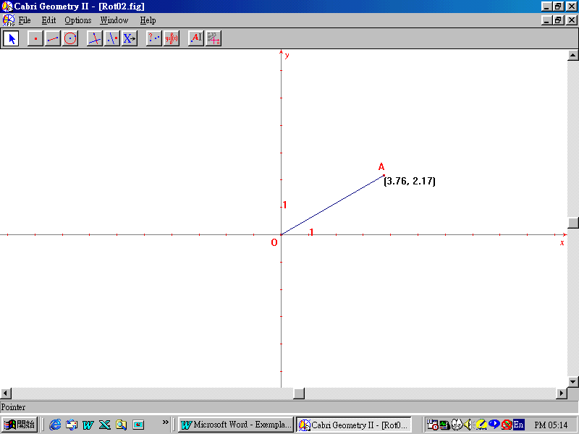
- Open the Cabri file Rot02.fig. You will find a point A joining to the origin O (see Fig.1).
Fig.1
- Select Numerical Edit from the Display toolbox.
- Click to place an edit box anywhere in the drawing window for creating an interactive number.
- Type the numerical value 90 in the box. Press Ctrl U to select Degree.
- Select Rotation from the Transformation toolbox. Click the point A, the origin O and the numerical value 90° to rotate the point A about the origin O by 90°. Label the rotated point as A'. Select Equation and Coordinate from the Measure toolbox. Click the points A and A' to indicate their coordinates.
- Select the Segment from the Lines toolbox. Draw the line segment OA'. Select Mark Angle from the Display toolbox. Select A, O and A' sequentially to mark the right angle AOA' (see Fig. 2 on next page).

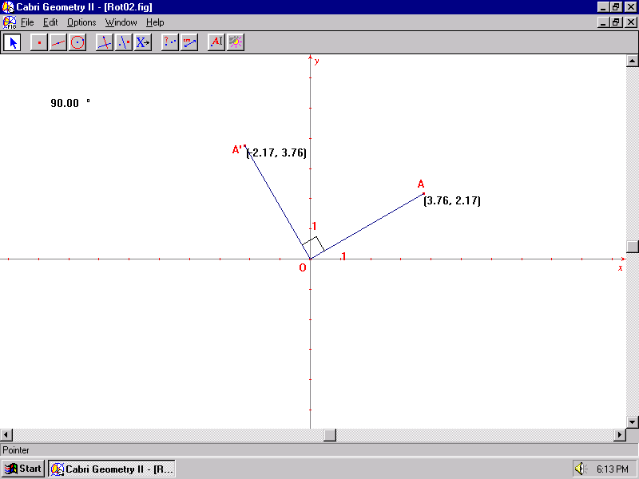
Fig.2
- Drag the point A to observe the changes in the coordinates of points A and A'. Record a set of coordinates of A and its rotated point A' in Table 1.
Angle of rotation | Coordinates of the point A | Coordinates of the point A'
90° | ( , ) | ( , )
 | ( , ) | ( , )
 | ( , ) | ( , )
 | ( , ) | ( , )
 | Conclusion
90° | ( x , y ) | ( , )
Table 1

- Change the angle of rotation to 180° and 270° subsequently and collect other 2 sets of data. Record them and summarize your conclusions in Tables 2 and 3. You can use the following steps to change the angle of rotation.
- Double click the angle to be rotated. You will find the arrow keys appear on the right hand side of the angle.
- Press the arrow up key or the arrow down key to modify the angle until 180°.
- Drag the point A to different positions. Record the coordinates of point A and its rotated point A' in Table 2.
- Repeat (a) to (c) for the angle of rotation as 270°.

Angle of rotation | Coordinates of the point A | Coordinates of the point A'
180° | ( , ) | ( , )
 | ( , ) | ( , )
 | ( , ) | ( , )
 | ( , ) | ( , )
 | Conclusion
180° | ( x , y ) | ( , )
Table 2

Angle of rotation | Coordinates of the point A | Coordinates of the point A'
270° | ( , ) | ( , )
 | ( , ) | ( , )
 | ( , ) | ( , )
 | ( , ) | ( , )
 | Conclusion
270° | ( x , y ) | ( , )
Table 3

Notes for Teachers:
- The objective of this example is to let students describe intuitively the effects of transformation on points in coordinate planes. Students only need to generalise their own investigations from a few data. Geometric proofs are advisable only for more able students.
- For those students who are keen on using Cabri, the teacher can ask them to try the exploration without using the given Cabri files.
- Answer for Worksheet 1:
Translation | Coordinates of the point A | Coordinates of the point A'
From O to ( a , b ) | ( x , y ) | ( x + a , y + b )
- Answers for Worksheet 2:
Axis of reflection  (The line L) | Coordinates of the point A | Coordinates of the point A'
the x-axis | ( x , y ) | ( x , − y )
2 units above the x-axis | ( x , y ) | ( x , 4 − y )
3 units below the x-axis | ( x , y ) | ( x , −6 − y )
- Answers for Worksheet 3:
Angle of rotation | Coordinates of the point A | Coordinates of the point A'
90° | ( x , y ) | ( y , − x )
180° | ( x , y ) | (− x , − y )
270° | ( x , y ) | (− y , x )
- In Worksheet 2, we only consider lines parallel to the x-axis as the lines of reflection. The teacher may modify the worksheet to let students investigate the effect of reflection of lines parallel to the y-axis. For very brilliant students, the teacher can even change the line of reflection with equation y = x for further exploration. This transformation is called the inverse transformation because the point ( x , y ) is transformed to the point ( y , x ).
- In Worksheet 3, we only consider the cases for rotation through 90°, 180° and 270° only. Teachers may modify the worksheet for the rotation through 360°, −90°, −180°,−270° and also −360°.
- The teacher may refer to Appendix C for Tools in Cabri Geometry II.

